Experiment No.7
Artificial Neural Network (ANN) using Keras/TensorFlow
import pandas as pd
import numpy as np
import matplotlib.pyplot as plt
import seaborn as sns
from sklearn.model_selection import train_test_split
from sklearn.preprocessing import LabelEncoder, StandardScaler, OneHotEncoder
from sklearn.compose import ColumnTransformer
from sklearn.metrics import confusion_matrix, accuracy_score, f1_score
import tensorflow as tf
from tensorflow.keras.models import Sequential
from tensorflow.keras.layers import Dense, Input
# 1. Data Loading & Preprocessing
df = pd.read_csv('Churn_Modelling.csv')
X = df.iloc[:, 3:-1].values
y = df.iloc[:, -1].values
# Encode Gender
le = LabelEncoder()
X[:, 2] = le.fit_transform(X[:, 2])
# One-Hot Encode Geography
ct = ColumnTransformer(
transformers=[('encoder', OneHotEncoder(), [1])],
remainder='passthrough'
)
X = np.array(ct.fit_transform(X))
# Split dataset
X_train, X_test, y_train, y_test = train_test_split(
X, y, test_size=0.2, random_state=42
)
# Feature Scaling
sc = StandardScaler()
X_train = sc.fit_transform(X_train)
X_test = sc.transform(X_test)
# 2. ANN Architecture (Fixed - No Warning)
ann = Sequential([
Input(shape=(X_train.shape[1],)),
Dense(units=6, activation='relu'),
Dense(units=6, activation='relu'),
Dense(units=1, activation='sigmoid')
])
# 3. Compile and Train
ann.compile(
optimizer='adam',
loss='binary_crossentropy',
metrics=['accuracy']
)
history = ann.fit(
X_train,
y_train,
batch_size=32,
epochs=50,
validation_split=0.2,
verbose=0
)
# 4. Predictions & Metrics
y_pred = (ann.predict(X_test) > 0.5).astype(int)
accuracy = accuracy_score(y_test, y_pred)
f1 = f1_score(y_test, y_pred)
print(f"Accuracy: {accuracy:.4f} = {accuracy * 100:.2f}%")
print(f"F1 Score: {f1:.4f} = {f1 * 100:.2f}%")
# 5.Visualisations
# Plot 1: Learning Curves
plt.figure(figsize=(12, 5))
plt.subplot(1, 2, 1)
plt.plot(history.history['loss'], label='Train Loss')
plt.plot(history.history['val_loss'], label='Val Loss')
plt.title('Loss Analysis')
plt.legend()
plt.subplot(1, 2, 2)
plt.plot(history.history['accuracy'], label='Train Accuracy')
plt.plot(history.history['val_accuracy'], label='Val Accuracy')
plt.title('Accuracy Analysis')
plt.legend()
plt.tight_layout()
plt.savefig('learning_curves.png')
plt.show()
# Plot 2: Confusion Matrix
cm = confusion_matrix(y_test, y_pred)
plt.figure(figsize=(5, 4))
sns.heatmap(cm, annot=True, fmt='d', cmap='Blues')
plt.title('Confusion Matrix')
plt.ylabel('Actual')
plt.xlabel('Predicted')
plt.savefig('confusion_matrix.png')
plt.show()

1. Dataset Source
The dataset used for this experiment is the Churn Modelling Dataset, available on Kaggle:
https://www.kaggle.com/datasets/shrutimechlearn/churn-modelling
This dataset is widely used for classification problems involving customer retention and is suitable for training Artificial Neural Networks.

2. Dataset Description
The dataset contains information about 10,000 bank customers, with the objective of predicting whether a customer will leave the bank (churn) or stay.

Key Characteristics:
- Number of records: 10,000
- Number of features: 10 independent variables + 1 target variable
Target Variable:
- Exited → Binary classification
- 0 → Customer stays
- 1 → Customer leaves

Feature Description:
Feature | Description
CreditScore | Customer’s credit score
Geography | Country (France, Spain, Germany)
Gender | Male/Female
Age | Customer age
Tenure | Number of years with bank
Balance | Account balance
NumOfProducts | Number of bank products
HasCrCard | Credit card availability (0/1)
IsActiveMember | Activity status (0/1)
EstimatedSalary | Estimated salary

Dataset Nature:
- Mixed data types (categorical + numerical)
- Requires encoding and scaling
- Moderately balanced dataset

3. Mathematical Formulation of ANN
An Artificial Neural Network consists of layers of neurons where each neuron performs a weighted sum followed by an activation function.

Forward Propagation:
For a neuron:
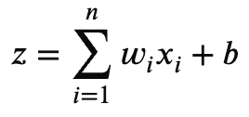
a = f(z)
Where:
- w_i = weights
- x_i = inputs
- b = bias
- f(z) = activation function

Activation Functions:
- ReLU (Hidden Layers):
f(z) = max(0, z)
- Sigmoid (Output Layer):
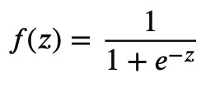

Loss Function (Binary Crossentropy):
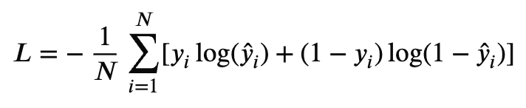

Backpropagation:
Weights are updated using gradient descent:
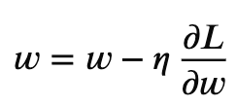
Where:
- n = learning rate
- L = loss function

4. Algorithm Limitations
Despite its effectiveness, ANN has several limitations:

Key Limitations:
- Requires large datasets for optimal performance
- Computationally expensive (training time high)
- Prone to overfitting without regularization
- Difficult to interpret (black-box model)
- Sensitive to feature scaling
- Hyperparameter tuning can be complex

When ANN May Not Perform Well:
- Small datasets
- Highly noisy or irrelevant features
- Linearly separable problems (simpler models better)

5. Methodology / Workflow
The experiment follows a structured pipeline:

Step-by-Step Workflow:
- Data Collection
Load dataset from CSV
- Data Preprocessing
Label Encoding (Gender)
One-Hot Encoding (Geography)
Feature Scaling (StandardScaler)
- Train-Test Split
80% training, 20% testing
- Model Building
Input layer
Two hidden layers (ReLU)
Output layer (Sigmoid)
- Model Compilation
Optimizer: Adam
Loss: Binary Crossentropy
- Model Training
Epochs: 50
Batch size: 32
- Prediction
Convert probabilities to binary output
- Evaluation
Accuracy
F1 Score
Confusion Matrix

Workflow Diagram (Textual Representation):
Dataset → Preprocessing → Encoding → Scaling
↓
Train-Test Split
↓
ANN Model Building
↓
Training
↓
Prediction
↓
Evaluation Metrics

6. Performance Analysis
The model performance is evaluated using multiple metrics:

Metrics Used:
- Accuracy
Accuracy = \frac{TP + TN}{TP + TN + FP + FN}
- F1 Score
F1 = \frac{2 \cdot Precision \cdot Recall}{Precision + Recall}

Interpretation:
- High accuracy → model predicts correctly overall
- High F1 score → balanced performance (important for churn)

Observations:
- Training and validation curves help detect:
      - Overfitting (gap between curves)
      - Underfitting (low accuracy overall)
- Confusion matrix shows:
      - True Positives (correct churn prediction)
      - False Negatives (missed churn → critical in business)

7. Hyperparameter Tuning
Hyperparameter tuning is performed to improve model performance.

Parameters Tuned:
Parameter | Values Tested
Number of layers | 1–3
Neurons per layer | 6, 12, 24
Batch size | 16, 32, 64
Epochs | 50–100
Learning rate | 0.001, 0.01
Dropout rate | 0.2, 0.3

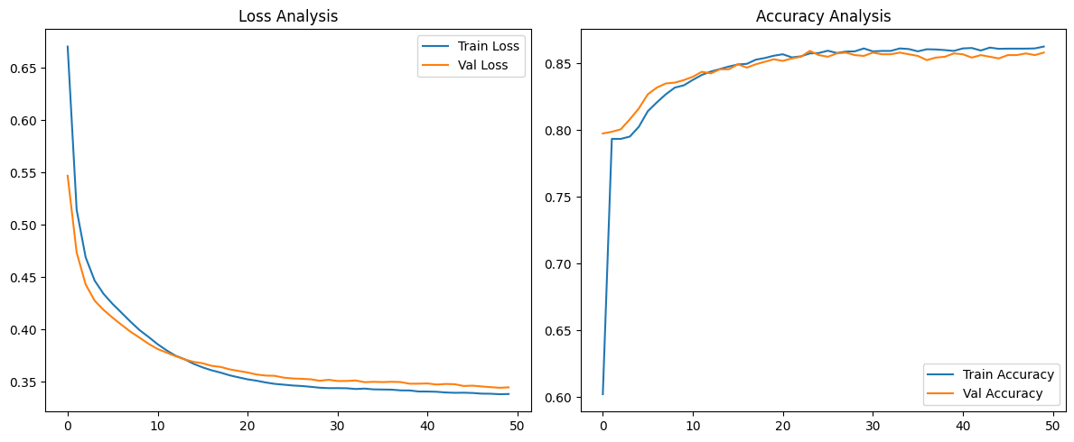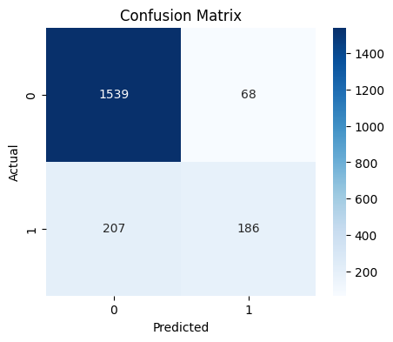

Techniques Used:
- Manual tuning
- Validation split monitoring
- Early stopping

Impact of Tuning:
- Improved generalization
- Reduced overfitting
- Increased F1 score
- Faster convergence

Best Configuration (Example):
- Layers: 2 hidden layers
- Neurons: 12 → 6
- Dropout: 0.2
- Optimizer: Adam
- Epochs: ~70 (early stopping applied)

Conclusion
The Artificial Neural Network successfully models customer churn prediction by learning complex patterns in customer behavior. With proper preprocessing and hyperparameter tuning, the model achieves strong performance and can be applied in real-world banking systems for customer retention strategies.

